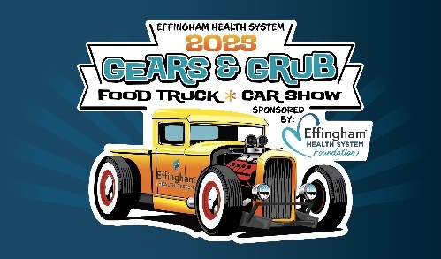

Effingham Health System’s
2025 Gears & Grub Car Show
Food Truck Application
Saturday, March 1, 2025 | 10:00AM to 4:00PM
Freedom Park, Rincon

There will be a limited number of food truck vendor slots at Effingham Health System’s 6th Annual Gears & Grub event. The event will be Saturday, March 1, 2025 from 10:00am to 4:00pm. Trucks will need to be checked in and set up NO LATER THAN 8:30 am. (LATE TRUCKS CAN BE REFUSED ENTRY) If you are interested in participating, please fill out this form and email it to Josh Forbes at joshua.forbes@effinghamhospital.org or amy.zeugin@effinghamhospital.org Applications must be received by February 1, 2025 to guarantee consideration.
Food Truck Fees: $250.00 entry fee (covers water, 120v electricity and ALL staff to work event). Dessert/Drink Truck fees are $150.00. Fees can be paid online at http://www.gearsandgrub.org or by check (Payable to EHS Foundation) and mail to 459 GA Hwy 119 S, Springfield, GA 31329. (Please add Food Truck in Notes Section)

Company Name: ____________________________________________________________________________
Name of Applicant: _________________________________________________________________________
Phone: _________________________________Email: _____________________________________________
Address: __________________________________________________________________________________
Number of employees working the event: ___________ (REQUIRED AHEAD OF TIME to receive wristband for FREE entry, otherwise employees will have to pay to enter event.)

Type of food you will be offering: ______________________________________________________________________________________________________________________________________________________________________________________
Vendor understands and agrees to operate “at your own risk policy” and by no means can hold any party responsible for any claims or losses. With your acceptance please sign below.

Signature: ________________________________________________ Date: _______________________

FOLLOWING INFORMATION REQUIRED WITH APPLICATION
- Your most recent Local Health Department Permit
- Copy of Certificate of Insurance

